Risk Matrix

|  |  |  |  |  |  |  |
| --- | --- | --- | --- | --- | --- | --- |
| risk | statement | response | Objective | Likelyhood | impact | risk level |
| procrastination | Unwilling to work in favour of more leasure | provide motivation to conduct weork | Increase leasurly ambience i.e.music while working or implement the fear element of not completing it | unlikely | minimal | **2** |
| Injury | Eye or back strain | Increase movement while working from a stationary position | Add exercise breaks in between working sessions | rare | minimal | **1** |
| Git-hub issues | User encounters a merge conflict where git fails at the start or during a merge | Identify the cause of conflict | Attempt to resolve merge conflicts | likely | moderate | **12** |
| Testing issues | The tests either fail to run or pass when they should be failing | Fix maven | Ensure maven is up to date and that the testing package is included in the build | possible | moderate | **9** |
| Lose all working files | Somehow manages to loose all working files | Make regular backups and commits | If this somehow happens the day before its due, just cry | rare | (extremely)n severe | **5** |
| Stuck on adding a feature | Struggling on implementing on a feature or unable to pass unit tests for said feature | Debug and fix | Use the debugger on eclipse to see exactly what is going wrong or use google to look up solutions for | likely | minor | **8** |

More risks will be added to the matrix as they become known

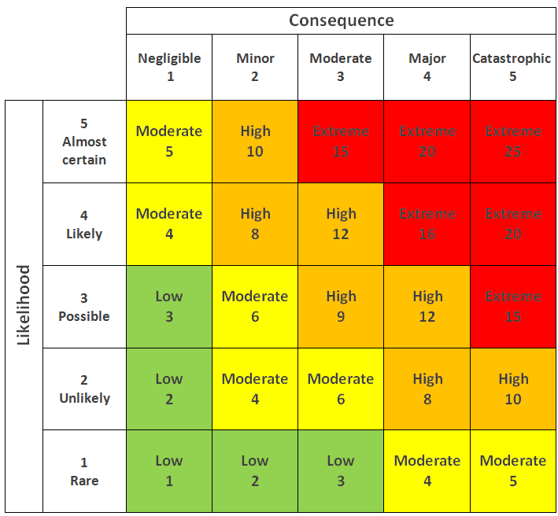

The key for the risk matrix.  
Image taken from:  
https://www.researchgate.net/figure/A-standard-risk-matrix_fig7_323570642